Administration Instructions

*UWA*

*Biosecurity Game*

By: Joel Dunstan

Personal Email: [jd427244@gmail.com](mailto:jd427244@gmail.com)

Work Email: [joel.dunstan@uwa.edu.au](mailto:joel.dunstan@uwa.edu.au)

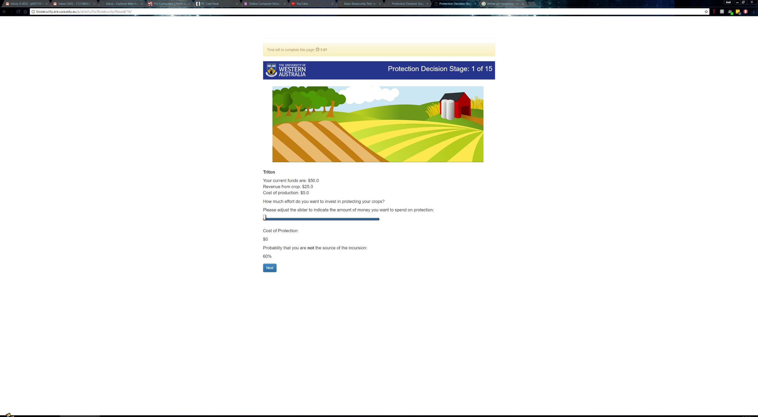biosecurity.are.uwa.edu.au

Table of Contents

Overview 3

How the Game is Played 3

Session Configurations 11

Freeform Communication Biosecurity Game 11

Monitoring Biosecurity Game 12

Pledging Biosecurity Game 12

Monitoring + Pledging Biosecurity Game 13

Approval on Pledges Biosecurity Game 13

Approval on Contributions Biosecurity Game 14

Being an Administrator 15

Lottery Game 15

Biosecurity Game 16

How an Outbreak is Determined 17

JavaScript Elements 18

Questionnaire and Results 18

How the Payoff is Calculated 19

Using the Website 20

The Demo Page 20

The Sessions Page 21

References 23

# Overview

This document will cover the use, modification and maintenance of the website, biosecurity.are.uwa.edu.au. This website is run from a UWA virtual server running with Dual Cores with Hyperthreading for a total of 4 threads/virtual cores and 16GB RAM. The instructions will first show you how to create a game, and along the way explain what each page is for. This will be done with an example game as shown from the website in its current state during May 2017 onwards. Secondly, the instructions will give you some idea on how to modify the game if needed, this will include links on places to learn python, oTree, Django etc. Finally, the instructions will explain how to maintain the website.

I heavily recommend you read the oTree documentation before reading this document, the oTree documentation is located here:

[oTree Documentation](http://otree.readthedocs.io/en/latest/index.html)

The documentation, includes tutorials, the description of oTree’s models, concepts and setup.

To learn how to use the website and administer a game, you must first learn how the game works and the way the game is played.

# How the Game is Played

To explain how the game works and how to play the game we will look at the game from the perspective of a participant in a game you’re administrating. We will call this participant, **Inigo**. Inigo has just sat down in front of a computer you have set up in such a way that you have opened a link on Google Chrome (as per the recommended web browser in the Test Document). Inigo will be greeted with this screen:

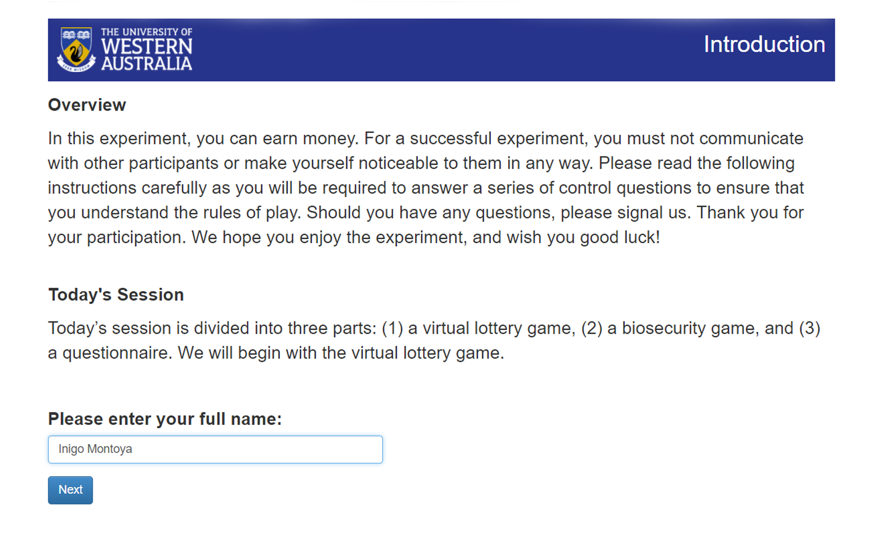What’s happening here while Inigo is reading the introduction to the game is that the UWA virtual server (which we will now call the Web Server) has received a http request from the computer Inigo is on. The web server receives this and in turns runs any Python code associated with this page in the models and views files and the Django, HTML and CSS code in the template that generates this page as you see it on a web browser (PCMag, 2017). This is how all the page’s work, some like the round page in the biosecurity game are more complicated and require JavaScript to change elements dynamically on-screen, the web server handles all the calculations, the only thing a participant like Inigo needs is a web browser and a device that can run a web browser.

Now back to Inigo, he has hit the ‘Next’ button by now which advances him to the next page, he will read the lottery game instructions (please read them [here](https://1drv.ms/w/s!AphuEhKWv8YUg4QgL2TgiEDscFOtcQ) or by playing the game). After Inigo has read the instructions, he will wait for all other participants to finish reading the game on a waiting page. After everyone has reached the waiting page, the game will load a control questionnaire that test’s his understanding of the lottery game. This will appear as so:

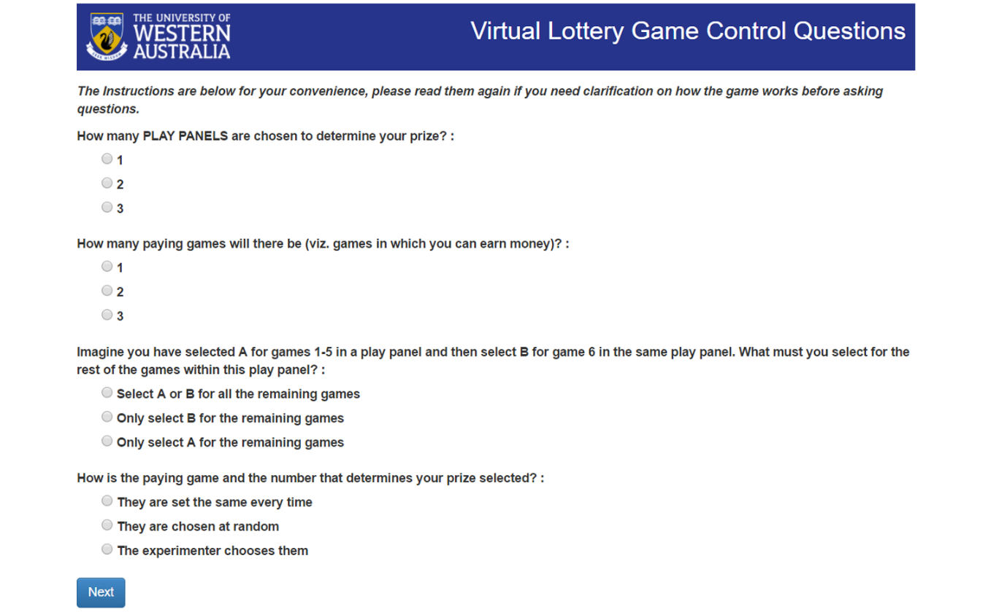

On this page, Inigo will choose answers and then hit next, if any of them are incorrect, the game will tell him after he clicks next. The game specifies which ones are incorrect by changing the text for the questions to red and labels them as incorrect underneath the question, e.g.

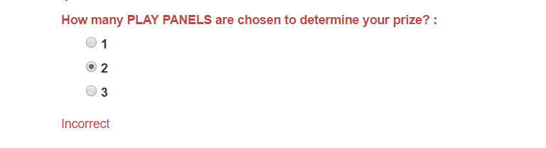

Inigo will only advance to the next page when he answers every question correctly, the instructions are provided below so Inigo can refer to them if he needs to remind himself how the lottery game works. Once everyone has correctly answered the questionnaire, Inigo and his group members will advance to the lottery game play panels where Inigo will choose his options for the lottery game that could determine his prize (or loss) for the lottery game. If you missed the link I provided you for the lottery game instructions, here it is again, [Lottery Instructions](https://1drv.ms/w/s!AphuEhKWv8YUg4QgL2TgiEDscFOtcQ), you’ll need to read them to understand how the game works.

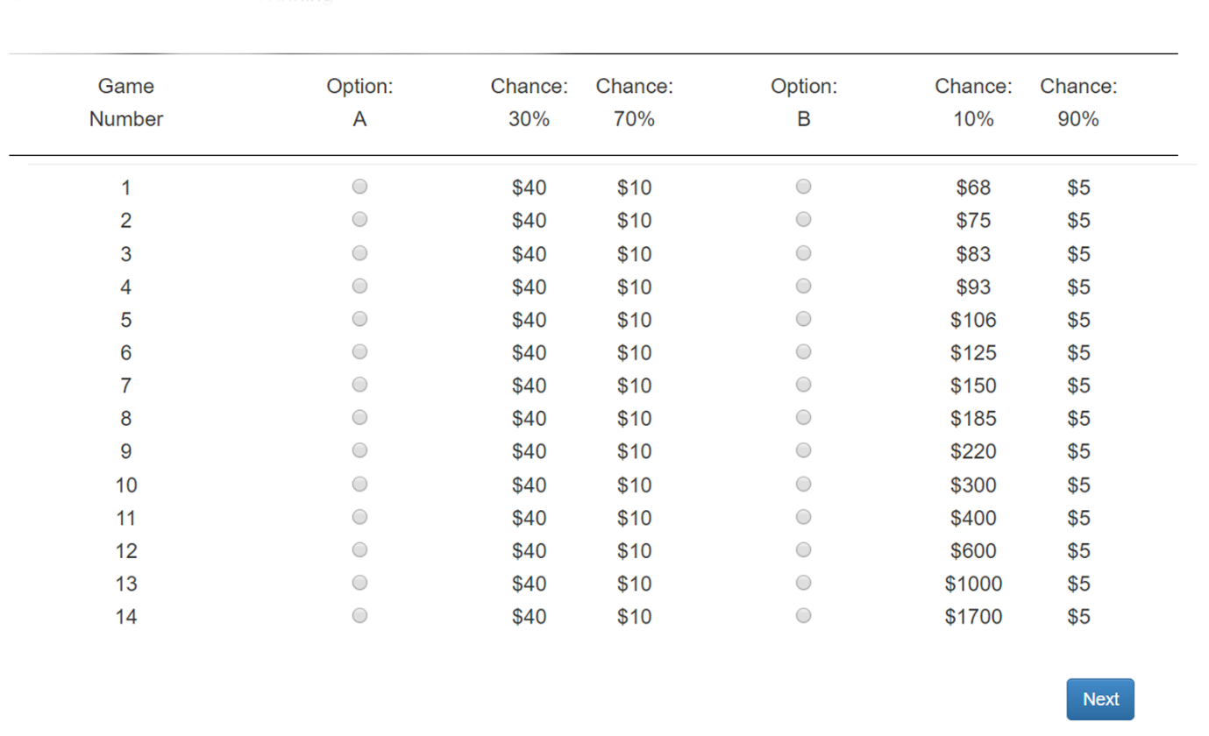The play panels will appear as so:

Inigo will choose his options, to assist Inigo there is JavaScript used in the template to ensure that once he chooses option B, the page will automatically select option B for the rest of the games. Since the lottery game can be played individually, Inigo will complete all three play panels without waiting for other participants to finish each play panel. A waiting page will only appear once Inigo has completed all three play panels and has therefore finished the lottery game.

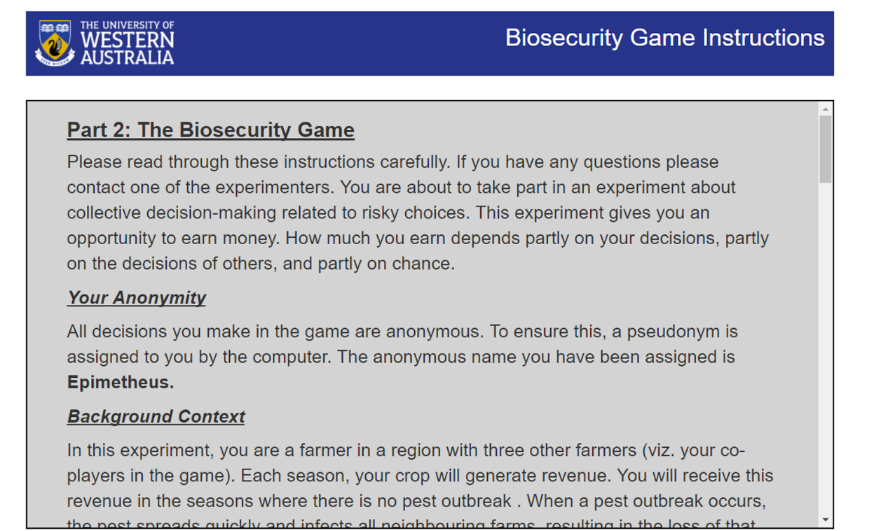Once everybody has finished the lottery game, the game will present the biosecurity game instructions to Inigo. The instructions will assign an anonymous name to Inigo, the name is chosen randomly from 25 names of planets and moons, Inigo received the anonymous name ‘Epimetheus’.

The instructions Inigo sees will be dependent on what session configuration of the game you set up for him. The different session configurations unlock different modes of the biosecurity game, this in turn requires different instructions which will be added into ‘The Stages’ section of the game. The session configuration Inigo is currently in, is the ‘Basic Biosecurity Game’, which is the barebones version of the game and will occur as you will see in this section. For the description of other session configurations, please refer to here. I encourage to read the instructions for the base version of the game yourself, get them [here](https://1drv.ms/w/s!AphuEhKWv8YUg4sDGR_IPMsebia6Sg).

After Inigo has read the instructions, the game will present him with a control questionnaire to ensure his understanding of the biosecurity game. These control questions will have same appearance as the control questions for the lottery game, like the lottery game, they will also tell Inigo if he got any incorrect. The control questionnaire does include questions on how joint probability works to ensure participants know how an outbreak is determined. Luckily, Inigo is good with maths and can handle joint probability, however just be aware some of your participants may not be so lucky.

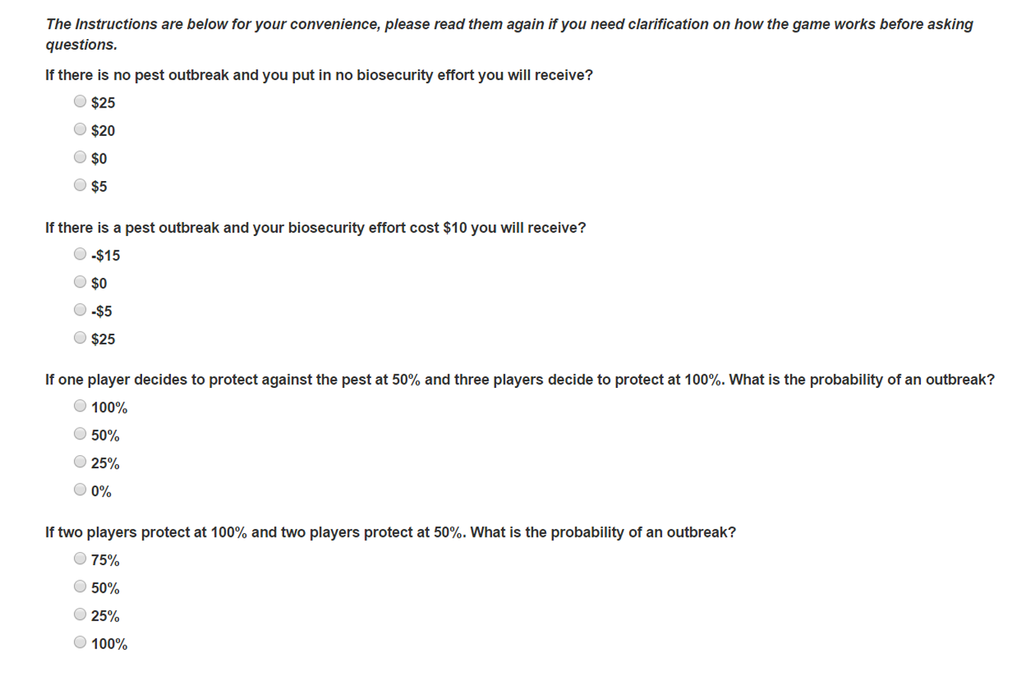These questions are retrieved from a CSV file inside the main project folder, an administrator can change these and their options, however, doing so means that one should reset the database used to hold all the data and restart the website. So before editing the questions, it is imperative to check that you have all the data for the games inside the database currently, once the data is gone, **there is no going back, there will be no way to retrieve them.**

After Inigo and his fellow group members have completed the control questionnaire, the biosecurity game begins. In this session configuration, there are no stages before Inigo will make his contribution towards the biosecurity effort, thus Inigo will be greeted with page below, please take note of the labels, they explain the elements of the page.

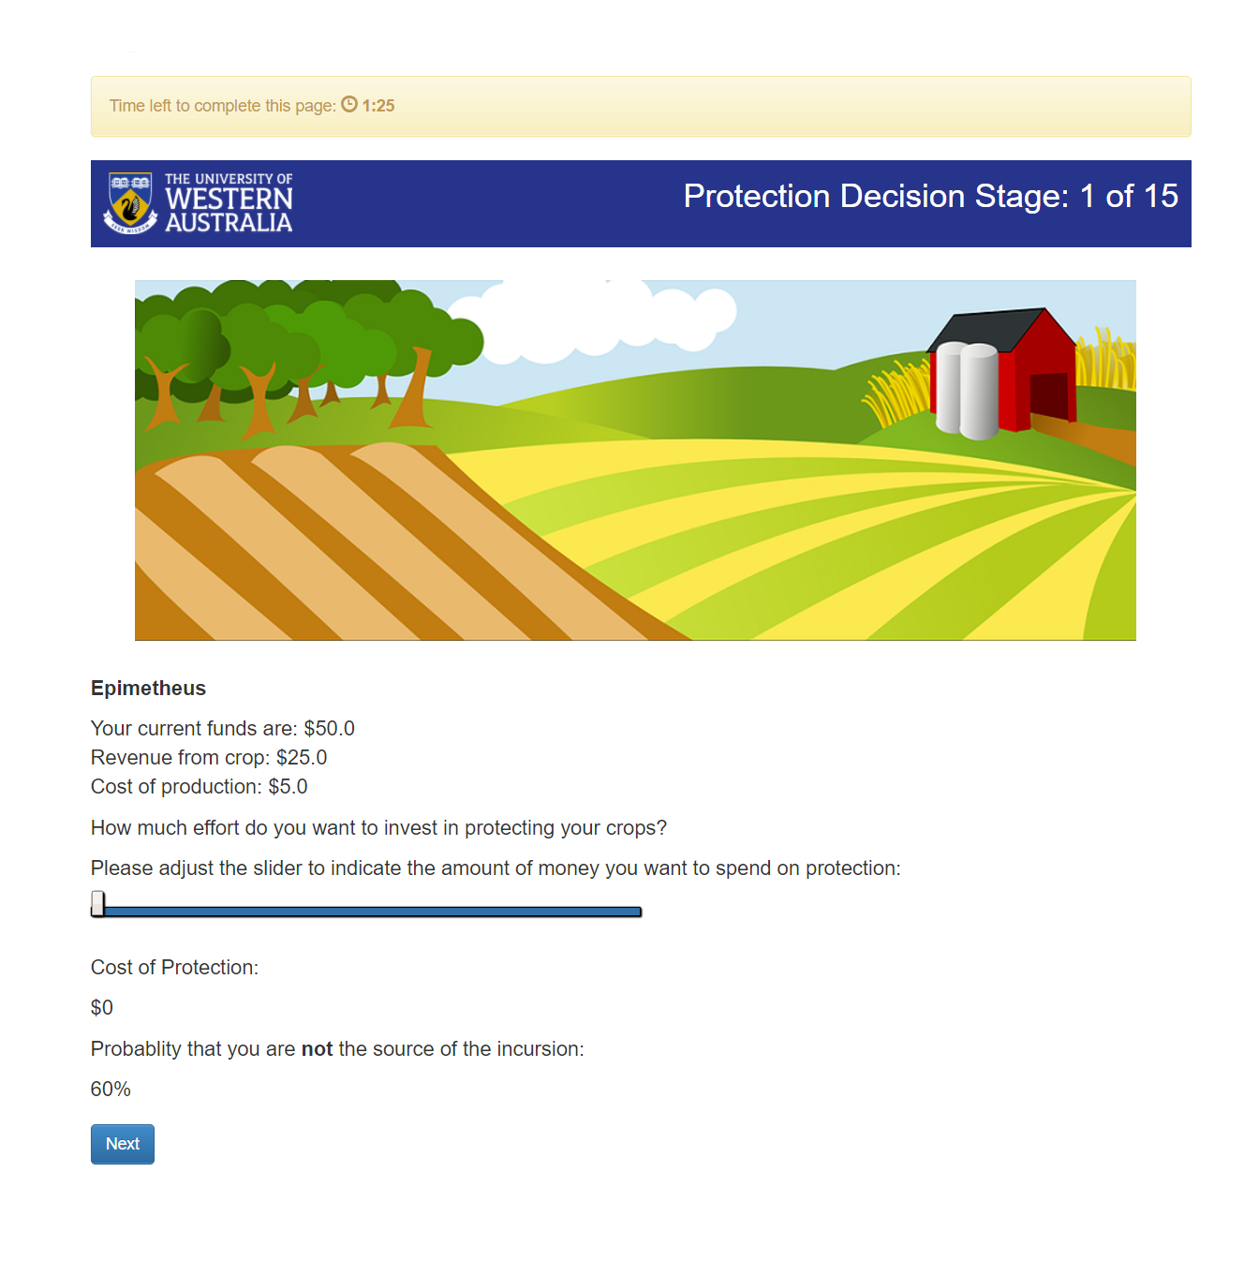

The participant’s anonymous name, while it has no significance in this session configuration, ‘Basic Biosecurity Game’, the anonymous name will be used in every other session configuration.

The slider is what a participant will use to determine the amount of effort they will contribute to the biosecurity effort. When the slider changes, the cost of protection and the probability that someone is not the source of the outbreak also changes using JavaScript to dynamically change these elements.

A timeout is put on the page, to ensure the game continues even if someone decides not to act. The timeout on the round is 1 minute and 30 seconds.

This is the round number, participants can keep track how many rounds there are left in the game.

outbreak:

Inigo and his fellow group members will use the slider to determine how much they will contribute towards the biosecurity effort in terms of dollars. The probability of Inigo not being the source of the outbreak is also shown, Inigo with his math skills could work out the groups joint probability of an outbreak by taking his own probability that he is not the source of the outbreak putting this to the power of 4, and then subtracting the result from 1 (e.g. 1 – 0.64 = estimated group’s probability of an outbreak). However, Inigo should not take too long to make his decision, there is a timeout of 1 minute and 30 seconds. Should Inigo fail to hit the next button thereby deciding on his biosecurity effort, the game will randomly choose the biosecurity effort (a value between $0 and the Maximum amount of protection). Throughout testing it was better for participants to make decisions rather than let chance completely decide their actions, not to mention it renders the experiment meaningless if participants start randomly choosing their actions.

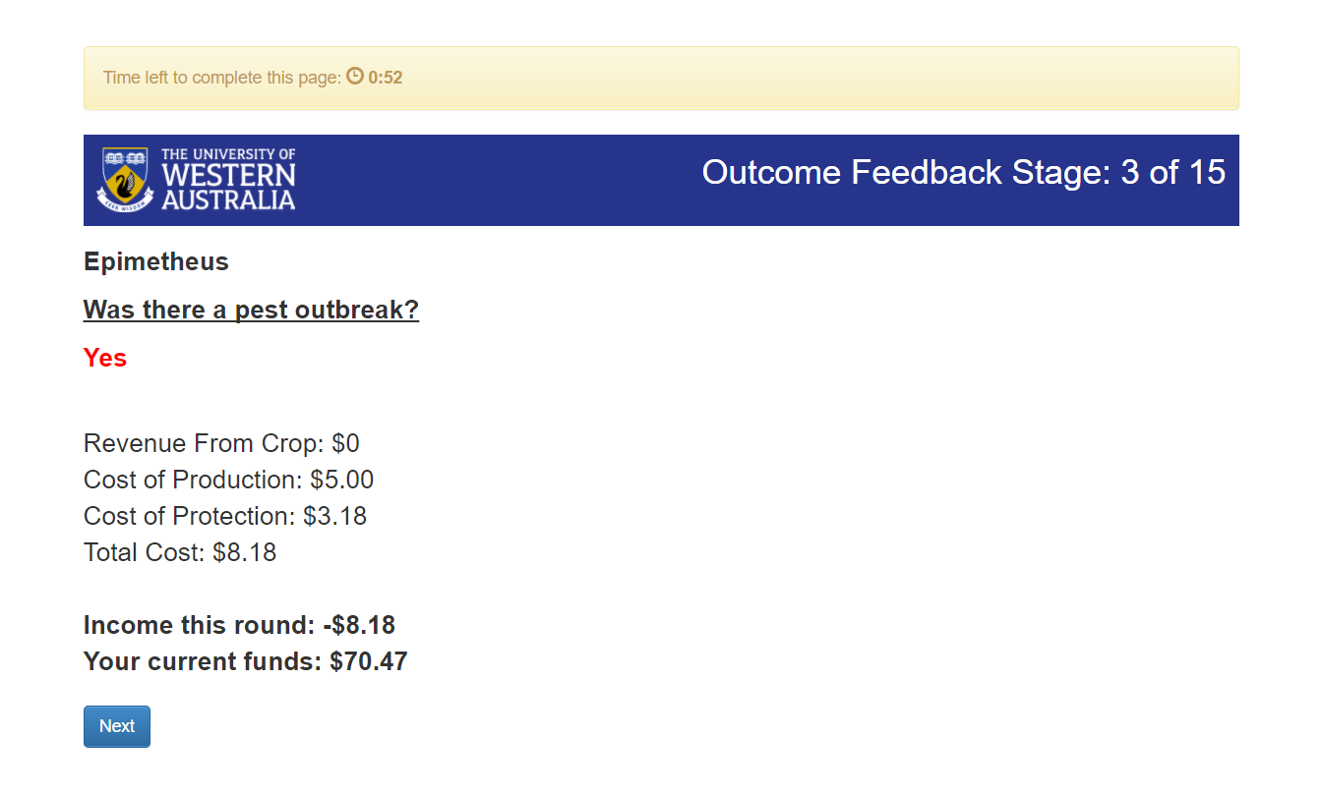If Inigo decided his biosecurity effort before the rest of his group members he will wait until the rest of his group members have made their biosecurity efforts. After everyone has made their biosecurity contributions, Inigo will be presented with the results page. The results page will show the income from the round, and whether there was an outbreak. If there was an outbreak Inigo will see the results page as below.

The anonymous name appears on every results page, this will be of big significance on every other session configuration where participants will see everyone’s biosecurity efforts including their own. In other configuration participants can use this anonymous name to communicate or give approval in some way. Thus, it is important, just not in this configuration.

Also, there some changes in the results page used to help participants immediately notice whether there was an outbreak or not. Take notice of how the yes is in red, and the no is green. Also, income is highlighted in bold so it’s one of the first things participants will look at, immediately indicating a loss or profit to the participant.

Inversely, if there wasn’t an outbreak, then Inigo will see the results page as below.

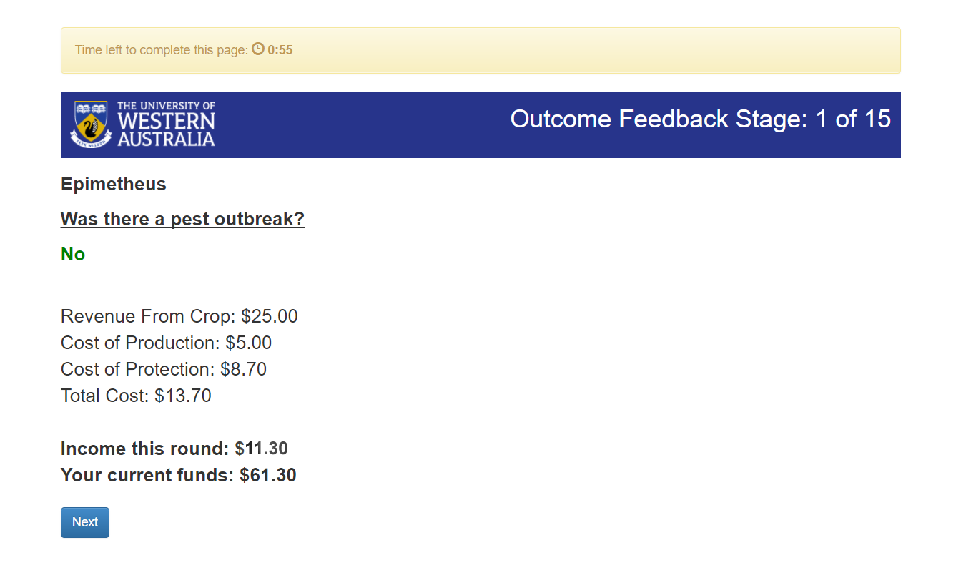

The total cost is indicated, should participants feel the need to see all the information without having to work it out.

As the game will continue into round 5 and above you will notice participants will only take note of all the words in bold, and the yes or no, and the game will progress quickly from here.

Please take note of the differences and text on the images.

Inigo, after seeing his first results page will continue the game for another 14 rounds, each round Inigo will decide his biosecurity effort alongside his group members and see the results. Finally, Inigo will finish the biosecurity game after completing 15 rounds with either a profit or loss.

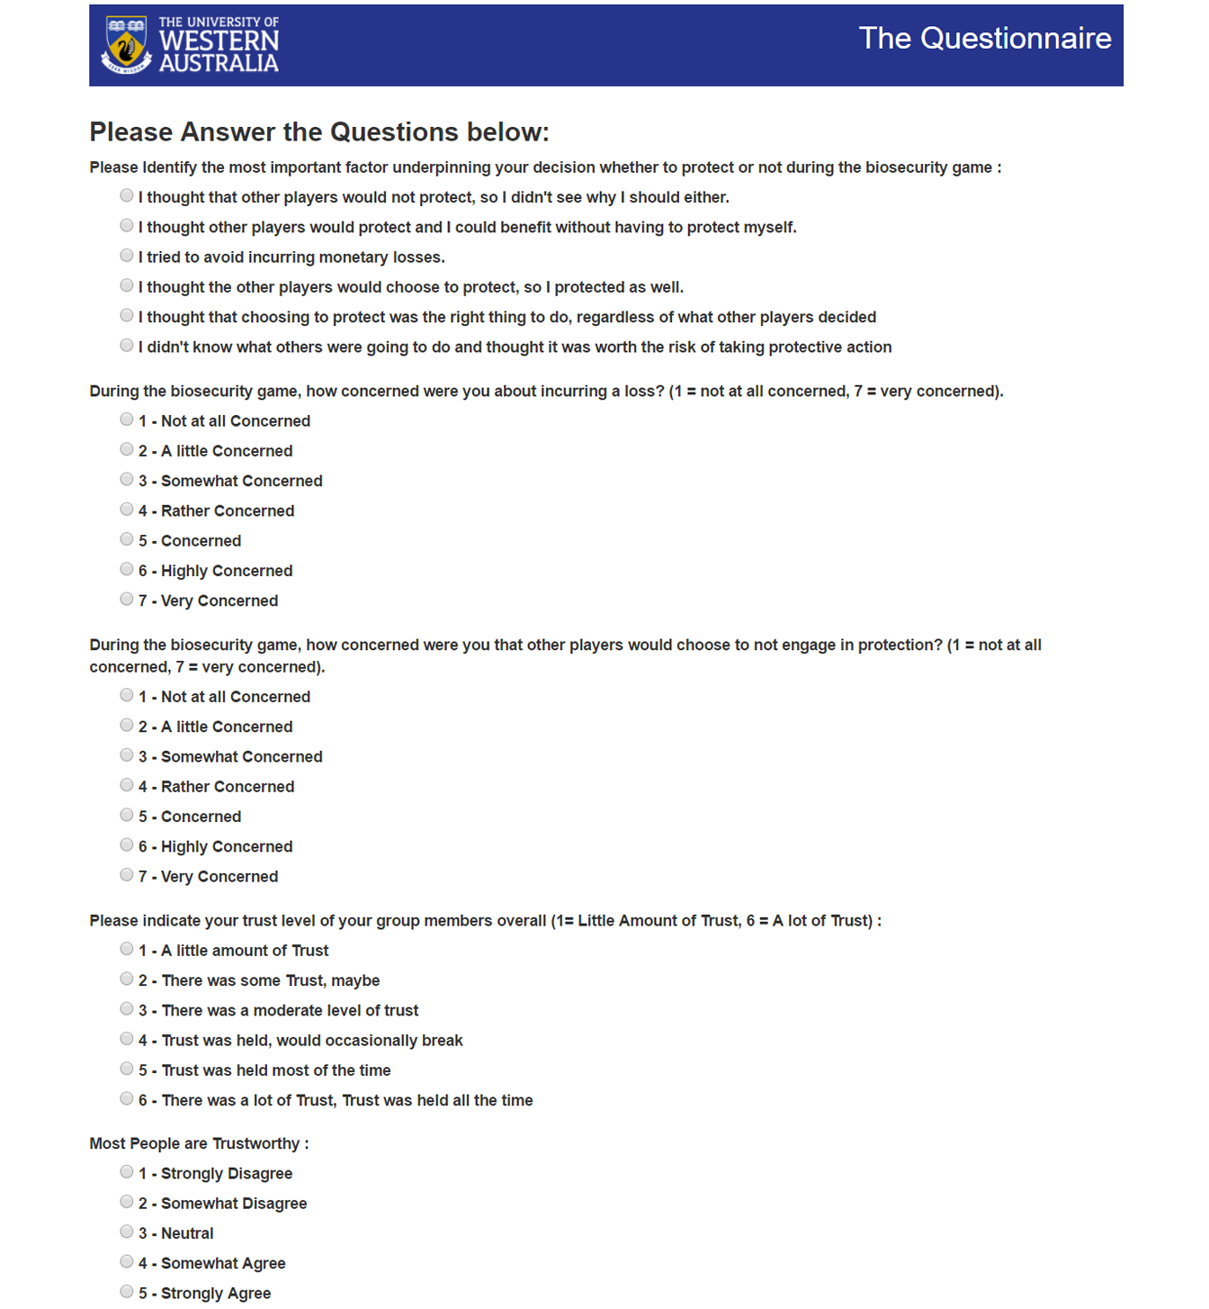Inigo will now proceed to a questionnaire which will ask him questions about the biosecurity game, his thoughts behind his decisions and how much he might trust his fellow group members etc.; questions about his gender, age, suburb and income are also asked.

Once Inigo and his group members have completed the questionnaire, they will have completed the game in its entirety and will be presented with the results of the lottery and biosecurity game.

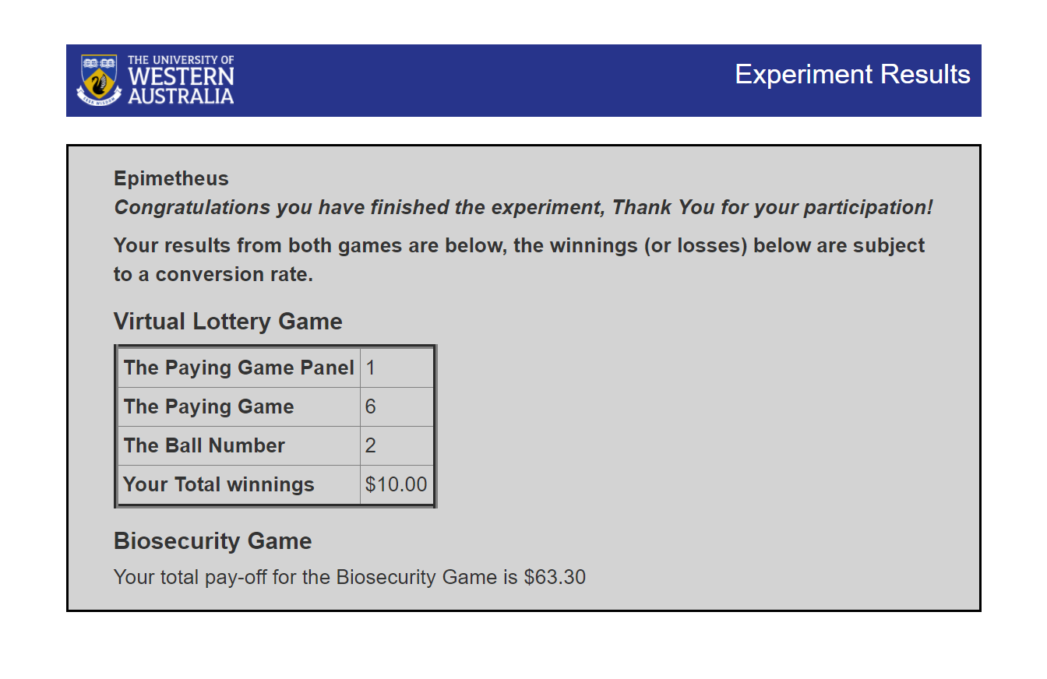Inigo and his group members will now receive their winnings from the game as per a conversion rate set by yourself in the currency of your choice.

# Session Configurations

As I mentioned in the previous section, there are multiple session configurations for the game. The difference between the session configurations can only be seen within the biosecurity game, the lottery game and the end questionnaire always remain the same despite a change in session configuration.

Some of these session configurations will make the game easier to play, and allow participants to communicate and coordinate with each other to increase everyone’s profit. However, they could also potentially cause larger rifts between participants in contrast to the base version, thereby increasing the loss instead. How the configuration affects the profits or losses of participants could be interesting in these cases. These session configurations are based on how farmers might coordinate their efforts and communicate with each other when protecting the community and themselves against biosecurity threats.

## Freeform Communication Biosecurity Game

This session configuration is exactly like the barebones version of the game except for an added chat stage which allows participants to anonymously communicate with each other using a chat box. The chat box will appear on the 1st, 6th and 11th round (every 5 rounds). No filters are present in the chat box, you can keep an eye on their conversation by clicking one of the links of the participants and watching it in real time. Hopefully, participants will remain civil and keep the chat relevant to the game, but there is no guarantee.

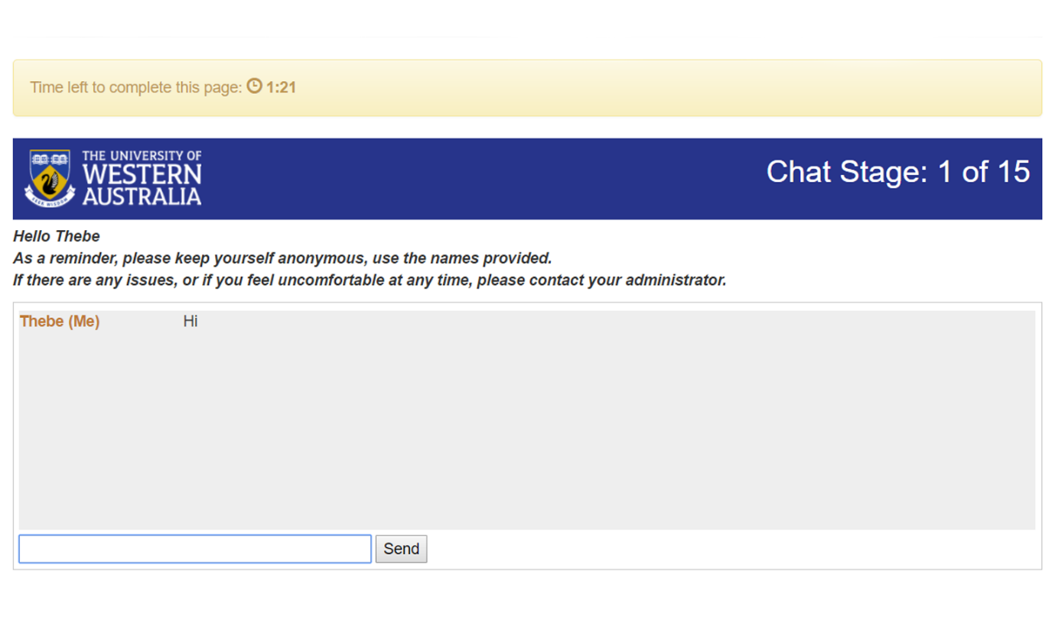

## Monitoring Biosecurity Game

This session configuration is like barebones version of the game except participants can see everyone else’s biosecurity efforts including their own during the results page of each round. However, participants have no way of showing their approval of these efforts.

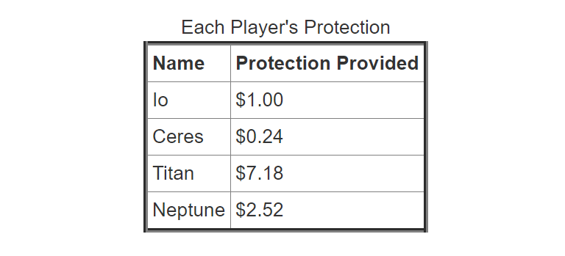

## Pledging Biosecurity Game

This session configuration adds two stages to the barebones version of the game, a group pledging and an individual pledging stage[1]. The group pledging stage happens at the start of every third round including the first round. In this stage participants choose what they think the joint probability of the group not having an outbreak should be.

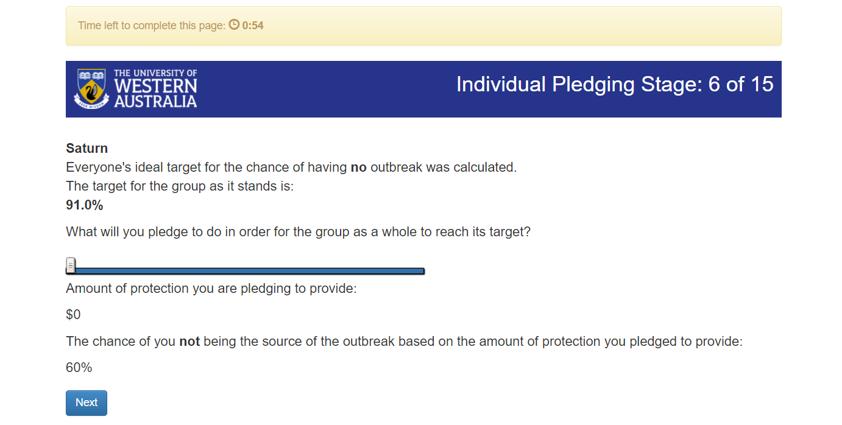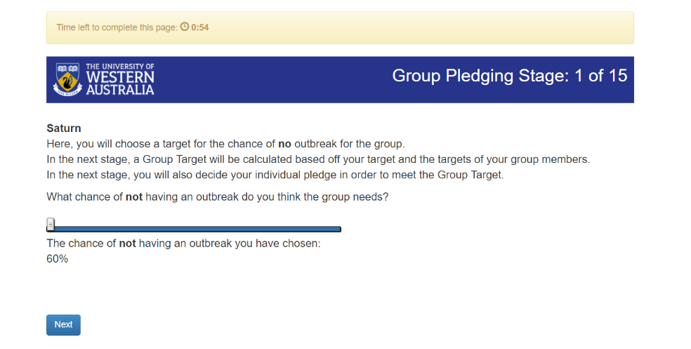Once participants have chosen their ideal probability of the group not having an outbreak, it will take the median of every participants ideal group target which produces the official group target that everyone should strive for. The official group target will appear in the individual pledging stage which occurs straight after the group pledging stage. In this individual pledging stage, each participant will pledge to do a certain amount of biosecurity effort per round for the next 3 rounds to reach the group target. However, there is no way for participants to show approval of everyone’s pledges during the round where they decide their biosecurity efforts and see everyone’s pledges including their own.

## Monitoring + Pledging Biosecurity Game

This session combines the Monitoring and Pledging Biosecurity Game session configurations together to have a game where participants can make pledges but also track whether other participants (including themselves) are keeping to their pledges due to participants being able to see everyone’s biosecurity efforts after each round.

## Approval on Pledges Biosecurity Game

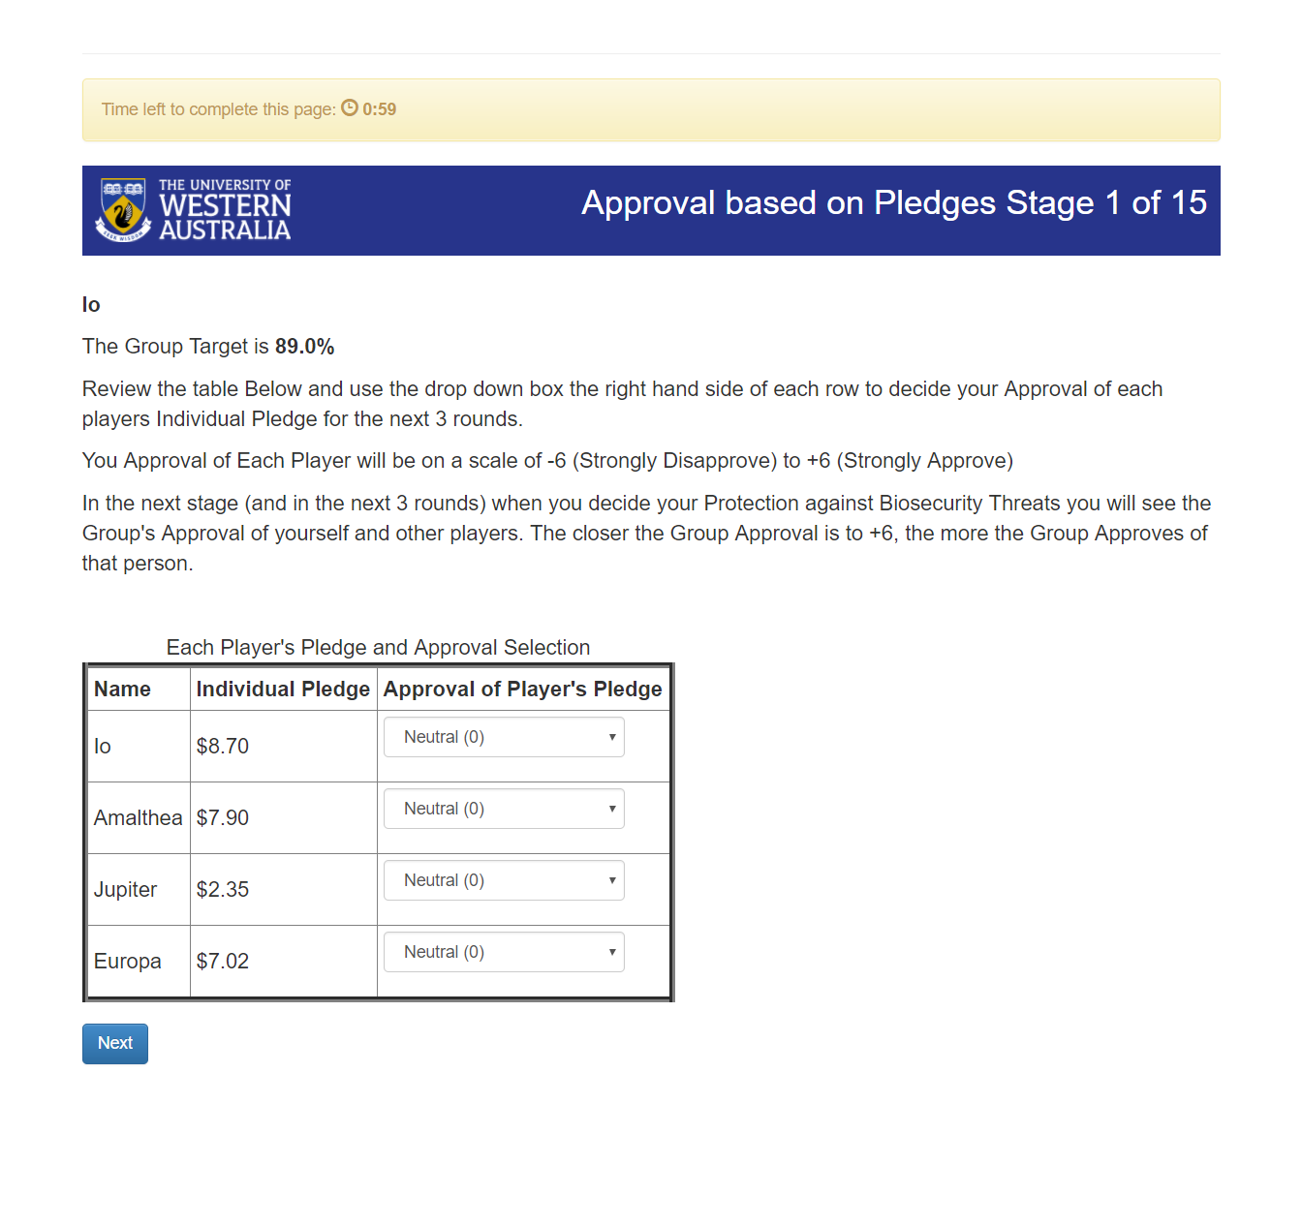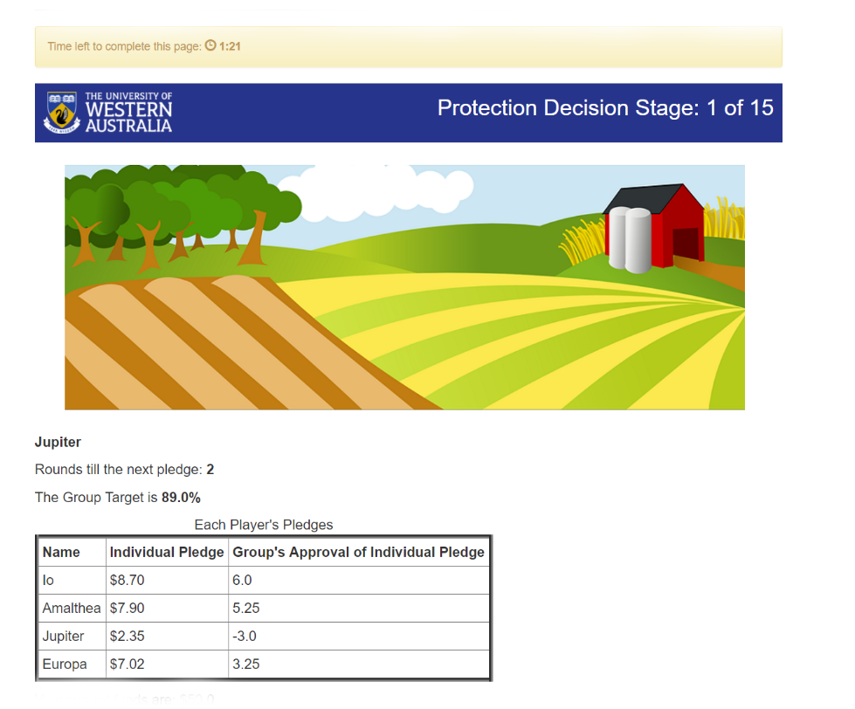This takes the previous session configuration, the Monitoring + Pledging Biosecurity Game and adds a new element where participants can show their approval of other participants pledges including their own[2]. The approval stage is after the individual pledging stage where participants indicate their level of approval of each pledge on a scale of -6 (Strongly Disapprove) to +6 (Strongly Approve). It displays all the relevant information in a table. During the main round where, participants will decide on their biosecurity effort they will see everyone’s group approval of their pledge. The group’s approval of a participant’s pledge is a mean taken from everyone’s approval of that participants pledge. The closer the group approval is to +6 the more the group approves of that participant’s pledge, inversely, the closer the group approval is to -6, the less the group approves of that participant’s pledge.

## Approval on Contributions Biosecurity Game

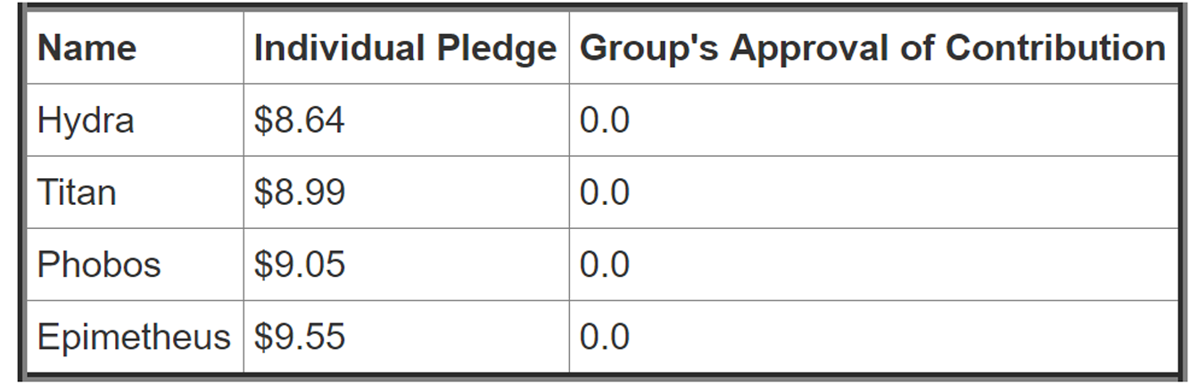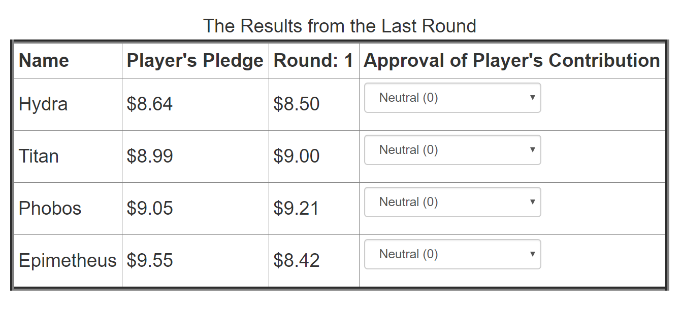This session configuration, like the Approval on Pledges Biosecurity Game, also adds an approval element to the Monitoring + Pledging Biosecurity Game[3]. The approval however focuses on the contributions of participants, instead of their pledges. In this session configuration, the pledging happens as before without approval on the pledge, however an approval stage now happens after the round’s results are shown. It will show the most recent pledge and the most recent contribution by each participant including themselves. Participants will then use the table to indicate their approval on a scale from -6 to 6 (the scale being the same as the Approval on Pledges Biosecurity Game). In the next round, it will show the group’s approval of the participant’s contributions.

# Being an Administrator

This section will focus on how Inigo’s game would look from an administrator’s perspective, or *your* perspective. As such this section will cover the specifics of how the game makes it decisions (random or otherwise), how to administer a game in terms of using the website biosecurity.are.uwa.edu.au and how to modify how the game works (or appears) without changing any of the underlying Python that the game relies on for its functions, equations and logic.

I will start with the specifics of the Lottery Game, Biosecurity Game and the Results containing the Questionnaire, and how participants are paid their reward. The sections below will explain the underlying functions and equations for each game, including how each participant’s reward is calculated based on their performance in the games.

## Lottery Game

In the Lottery Game, each participant receives a total of 3 Play Panels, these play panels have up to 15 games, there is a total of 35 games and each game has two options, A or B.

Referring to the play panel above, I will explain how the lottery game chooses the winning game and how each participant determines how much they win. First, the lottery game randomly selects 1,2 or 3, each number representing a play panel. In this case, it randomly selected 1, thus it chose play panel 1. Secondly the game will randomly generate a number between the lowest game number to the highest game number inclusive, in this case it’s a random number between 1 and 14 inclusive. As an administrator, you should be aware that on play panel 1, it will only select games 1 to 7 due to the high monetary values included from games 8 to 14. If you’re wondering why this is the case, consider this, even when a conversion rate of 0.1 is applied, you could be paying participants the equivalent of $170 in the currency of your choice when a participant wins through option B on game 14.

Now back to the game, the random game that was chosen is game 2. Now, in this lottery game, a number between 1 and 10 is randomly generated, it is this number and the option chosen by a participant that determines exactly how much a participant wins. For example, in game 2, let’s examine two scenarios, in the first scenario, a participant chooses option A. For a participant to win $40, the randomly generated number must be between 1 and 3 inclusive, out of a possible 10 numbers, hence a participant has a $\frac{3}{10}$ probabilityor 30% chance to win $40. If the randomly generated number was between 4 and 10, then the participant would win $10, hence a participant has a $\frac{7}{10}$ probability or 70% chance to win $10.

The second scenario for game 2 is a participant choosing option B. The scenario will play out much like the first, however, for a participant to win $75, the randomly generated number must be 1, thus a $\frac{1}{10}$ probability or 10% chance of winning $75. Thus, leaving a $\frac{9}{10}$ probability or 90% chance of participant winning $5.

The probabilities of the random number between 1 and 10 apply throughout the entire play panel. For example, for every game inside play panel, option A always has a 30% chance of winning $40 and option B will always have a 10% chance of winning the higher monetary value.  
  
To summarise…

A random number is generated between 1 and 3 (inclusive) this is the **winning play panel**.

A random number is generated between the lowest and highest game number, this is the **winning game.**

A random number is generated between 1 and 10 (inclusive), and a participant will choose an option in the winning game. It is these two variables that determine a **participant’s prize**.

To ensure participants play the lottery game correctly, there are safe guards. The first being that when a participant chooses option B, it will select option B for the rest of the play panel, this will be explained in the instructions for the game. Secondly, the game numbers, monetary values and text is read from a CSV file, making it harder for someone to edit the values using a developer mode inside a web browser to change the values thus making the data invalid. Finally, there is a lottery game control questionnaire to ensure understanding of the game.

If the lottery game runs as expected and participants play correctly, then you will have an idea of how risk aversive a participant is, indicating how they might act (or did act) in the biosecurity game. At the very least, it can help explain the actions a participant made in the biosecurity game.

## Biosecurity Game

In the Biosecurity Game, there is a total of 15 rounds, each round participants will decide their biosecurity effort against biosecurity threats to prevent outbreaks and to gain a profit from each round. In this section, I will explain the nature of how the game calculates the probability of an outbreak and uses a random function to decide whether an outbreak occurs, which will result in the participant receiving a profit or loss. I will also go through how the biosecurity game uses certain JavaScript elements for the sliders present on the website. Now there are a few defaults that are existent across every session configuration, these defaults are as follows:

* The maximum amount of protection (or biosecurity effort) someone can offer against biosecurity threats per round is $10. This default will be labelled as **MP**.
* The minimum probability that a participant isn’t the source of the outbreak is 60% (0.6). This will be labelled as **PC**.
* The revenue for each round when no outbreak occurs is $25. Participants will receive no revenue when an outbreak occurs as the whole round’s crop is lost. This will be labelled with **R**.
* The upkeep, or the cost of production for crops per round is $5. This will be labelled with **U**.
* The starting funds for each participant is $50.
* The calculator showing a participant’s probability of them not being the source of the outbreak is always available.
* A participant automatically receives the equivalent of $10 in their local currency for playing the game (exceptions can be made at your discretion, depending on your moral and ethical obligations)
* The conversion rate from the game’s monetary amounts to the local currency is 0.1.
* The players per group is 4.

The point of the Biosecurity Game is to see the psychological, economical, and biological effects of biosecurity, focusing more on the psychological and economical. The psychological effects under the microscope are the group’s trust of each other and how people act (and react) when participating in programs devoted to biosecurity, where the risk of outbreak is relatively high. The economic factors come into it, when we analyse the patterns that exist when participants play the game, to see if they put themselves in a Nash equilibrium, or consider how other participants will act, and adapt based on this educated guesses or information. Morality factors do come into the game as well, but the effects one’s morality has on the game is investigated in the questionnaire after the biosecurity game.

Any biological effects can be inferred from the number of outbreaks in each game, and administrators could use this to possibly anticipate the severity of the impact of agricultural industries not properly following biosecurity laws. Although, the experiment alone will only take a small part in looking at biological factors, only supporting any conclusions on biological effects from certain biosecurity threats, and the how agriculture could affect its environment.

Now to explain, how an outbreak is determined, and how a participant receives a profit or loss.

### **How an Outbreak is Determined**

C = Amount of protection a participant put in that round ($0 ≤ P ≤ MP)  
  
P1, P2, P3, P4 = The probability that a participant (4 participants in this scenario) is NOT the source of the outbreak (0.6 ≤ P1, P2, P3, P4 ≤ 0.9995). Will be denoted as **Px** when referring to the function for P1-4.

**RAND =** A random number between 0 and 1 generated by the server  
   
1) Get the Cost Factor:

**CF = $-\frac{MP}{ln(1-0.9999+PC)}$**

2)Determine the probability that a participant is the source of the outbreak:

**Px =**3)Determine the probability of no outbreak for the group (the set of participants containing P1­ – P4):

**Probability of No Outbreak (PNO) = P1** x**P2** x**P3** x**P4**

4) Determine the probability of an outbreak for the group:

**Probability of an Outbreak (PO) = 1 – PNO**

5) Now generate a random number between 0 and 1 and follow the inequalities below:

**if PO > RAND, Outbreak Occurs**

**if PO < RAND, No Outbreak Occurs**

6) Now determine each participant’s profits or losses as per the following functions:

If there was an Outbreak, then: **Current Funds = Current Funds – C – U**

If there was no Outbreak, then: **Current Funds = Current Funds – C – U + R**

### JavaScript Elements

In the biosecurity game, sliders appear during various stages depending on the session configuration. The slider I want to discuss is in the page where participants decide their biosecurity effort against biosecurity threats (and by extension, the individual pledge page which uses the same slider).

The slider above utilises JavaScript functions to dynamically change on-screen in front of participants. Namely, using an ‘onchange’ tag within HTML’s range input type, we call a function which simply changes the text on screen. The function that changes the text on screen retrieves the slider’s current value when a participant drags the cursor along the slider, and then uses the slider’s value as the **C** value in the equation from step 2 in How an Outbreak is Determined. The JavaScript from here takes the output of the equation, multiplies it by 100 to present the output as a percentage, and then adjusts a HTML block denoted by a div tag, to display the output. The function also manages the presentation of the cost value displayed as ‘Cost of Protection’, displaying the slider’s value as a monetary value.

## Questionnaire and Results

The questionnaire that occurs after the game asks some questions about the participants experience during the biosecurity game, namely their motivation behind their actions and the trust of their group members. The questionnaire will also ask participants some questions that incorporate some thinking about morality, their answers to these questions can give an indicator how much their own morality impacted their decision making. For example, consider the 1st question asked in the questionnaire:

*Please Identify the most important factor underpinning your decision whether to protect or not during the biosecurity game?*

One of the possible answers to this includes ‘I thought that choosing to protect was the right thing to do, regardless of what other players decided’, a participant answering the question above with this answer can give you an indication that a participant made decisions based on their morality, rather than an idea of profit or loss. The Questionnaire does include questions about their gender, age, suburb, postcode and their annual income so an administrator like yourself can categorise results based on socio-economic categories.

The Questionnaire is generated from a CSV file inside the “CSV” directory within the project. The program reads the CSV file, taking values from the ‘question’ column to grab the question, and the values from the ‘choices’ columns to display the options each participant must choose from. The ‘type’ column, dictates the type of question it is, most are multiple-choice questions and hence are denoted using choice, others like the age or suburb are different and require distinct types. The lottery and biosecurity game control questionnaires that test a participant’s understanding of the instructions and the game, also work the same way, except for having an ‘#correct’ column inside the CSV files containing the questions. Since these questions have correct answers, we need to specify which answer is correct, the ‘#correct’ column contains integer values which dictates which choice is correct. For example, if ‘#correct’ has a value of 2, then the column ‘choice2’, contains the correct answer.

## How the Payoff is Calculated

Before the final questionnaire about a participant’s experience, there is a wait page that occurs for only one purpose, to adjust the payoff for each participant for the lottery and biosecurity game. It is here that one must understand how oTree calculates how it stores how much you’ll need to pay each participant. In oTree, each participant has a payoff that is associated with each application, this is stored within the player class of that application. To calculate how much you owe each participant, it adds all the payoffs inside the player class from all the applications, and stores this value inside a participant variable called ‘payoff’, which persists throughout each session. This ‘payoff’ participant variable is what gives your value inside the Payments Tab which will be explained here (add link 🡨). Please keep in mind that when looking at the Payments page, that the indicated monetary gain for the participant is most likely incorrect until this important wait page occurs.

The reason for this is due to the ethical obligations of the experiment for which this game was made. Thus, we had to apply the following rules to ensure participants earned money or didn’t lose money from the participation fee (the money a participant receives for participating in the experiment):

1. If a participant won money in the Lottery Game, but made a loss in the Biosecurity Game, then we add the absolute value of the loss in the Biosecurity Game, thereby cancelling out the loss from the Biosecurity Game, leaving the participant with only the gain from the Lottery Game.
2. If a participant made a loss in the Lottery Game, but made a profit in the Biosecurity Game, then one of two scenarios will occur:
   1. If the profit made from the Biosecurity Game is larger than the loss from the Lottery Game, then the loss from the Lottery Game is subtracted from the Biosecurity Game profit. This is the case where the payoff participant variable will show the correct result before and after the wait page, as a participant earns money.
   2. If the profit made from the Biosecurity Game is less than the loss from Lottery Game, then the total profit from both games will be $0, to ensure the participation fee isn’t affected.
3. If a participant made a loss in both the Biosecurity and Lottery Game, then the total profit from both games will be $0 to ensure the participation fee isn’t affected.

## Using the Website

While these sections will likely echo from information that can be found in the oTree documentation, I still feel the need to explain how to use the pages and what to expect when looking at the oTree administration site. I feel this is necessary as the documentation focuses more on the development of an oTree project (and perhaps rightly) forgoes the need to explain how to use each page, as each administration oTree site could look slightly different depending on the needs of developers and their clients or experiments. For each page, I will explain the purpose that each page serves alongside a labelled image explaining elements of the page. The combination of the image and explanation should tell you how to use the page and why you should use it. Most pages are intuitive to use, so don’t worry, learning to use the site should be easy for you, no matter your knowledge level.

### The Demo Page

The first thing you will see when loading biosecurity.are.uwa.edu.au is a login screen, the first text box will be the username, and the second text box will be a case sensitive password which as an administrator you should have access too. Once you have input correct credentials, you will be greeted with the Demo Page, it is here that you will see a list of the session configurations and welcome text (subject to change). Clicking on one of the session configurations will start a demo session, this demo session is volatile in the sense that once you close the tab/window in which the administration page of the demo resides, you will lose the ability to control the demo session, or see its results. This demo page is about testing the session configurations and experiencing the games (mostly) without consequence to the data that you are storing. You might want such features to show colleagues how the game works without having to start a session and configure it, or in the case of development, test an application or session configuration.

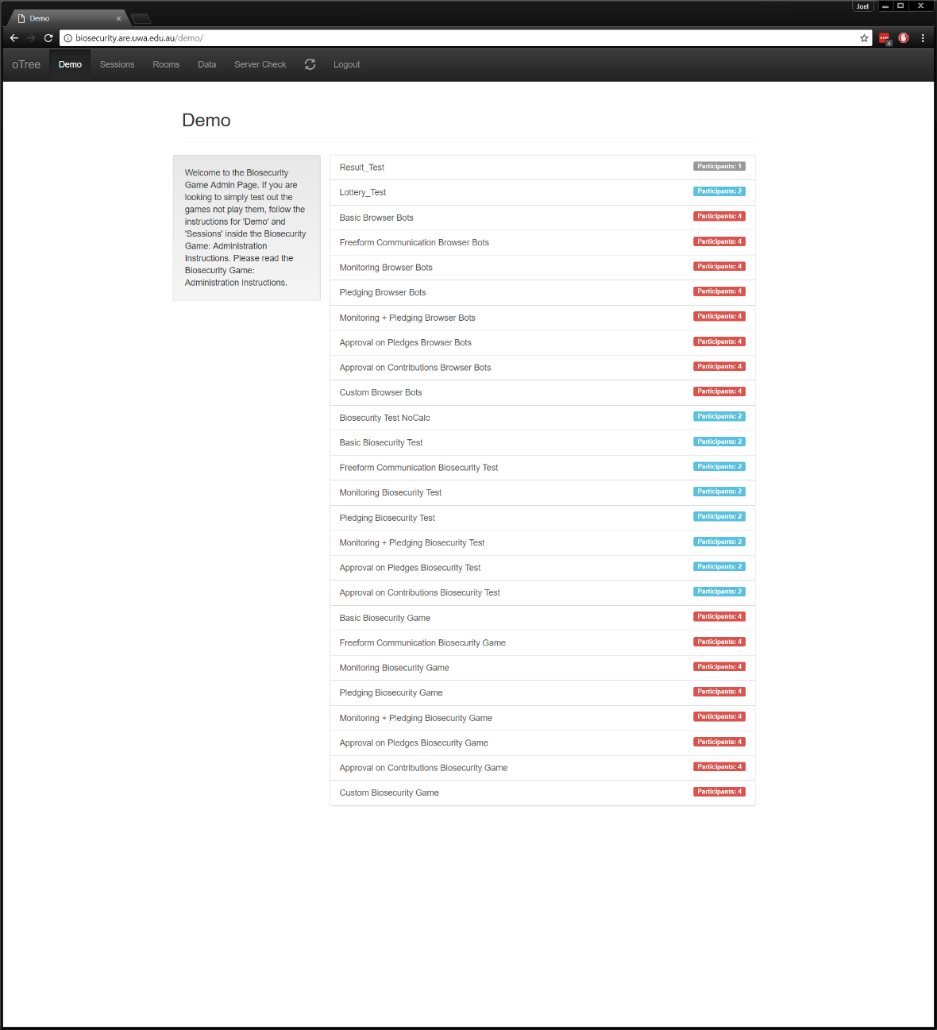

This is the **Main Menu**; the current page is highlighted in a darker colour.

The welcome text (subject to change) introduces to the website and other documents you should be aware of, like the one you’re reading!

The list of session configurations shows the name of the session configurations and the number of participants a demo session will default to. For example, ‘Basic Biosecurity Game’ is a session configuration that will have 4 participants and run the entire game from Lottery to Biosecurity to the end Questionnaire.

The number of participants that the corresponding demo session will have.

### The Sessions Page

The sessions page will end up being the page where you as an administrator will spend most of your time, it’s on this page where you will create and administer sessions. Upon entering the page, you will see a list of your sessions that you have created, each could be in varying stages of completion. However, if you have no sessions then you’ll need to create one to start a session lets start there. First, you’ll need to click the ‘Create New Session’ which will greet you with the two forms. The session config is a drop down menu where you will select the particular game you want to run a session with and remember that the number of participants is the number of participants in the session, not the number of participants per group. If you want more control over the variables used in the session and the game in particular then click ‘Configure session’ which will reveal the variables that you can change in order to change how the game works. For example you could configure the session to have more than 4 participants per group, set a higher revenue or change the minimum probability of no outbreak etc. For more detail refer to the annotated images below and on the next page.

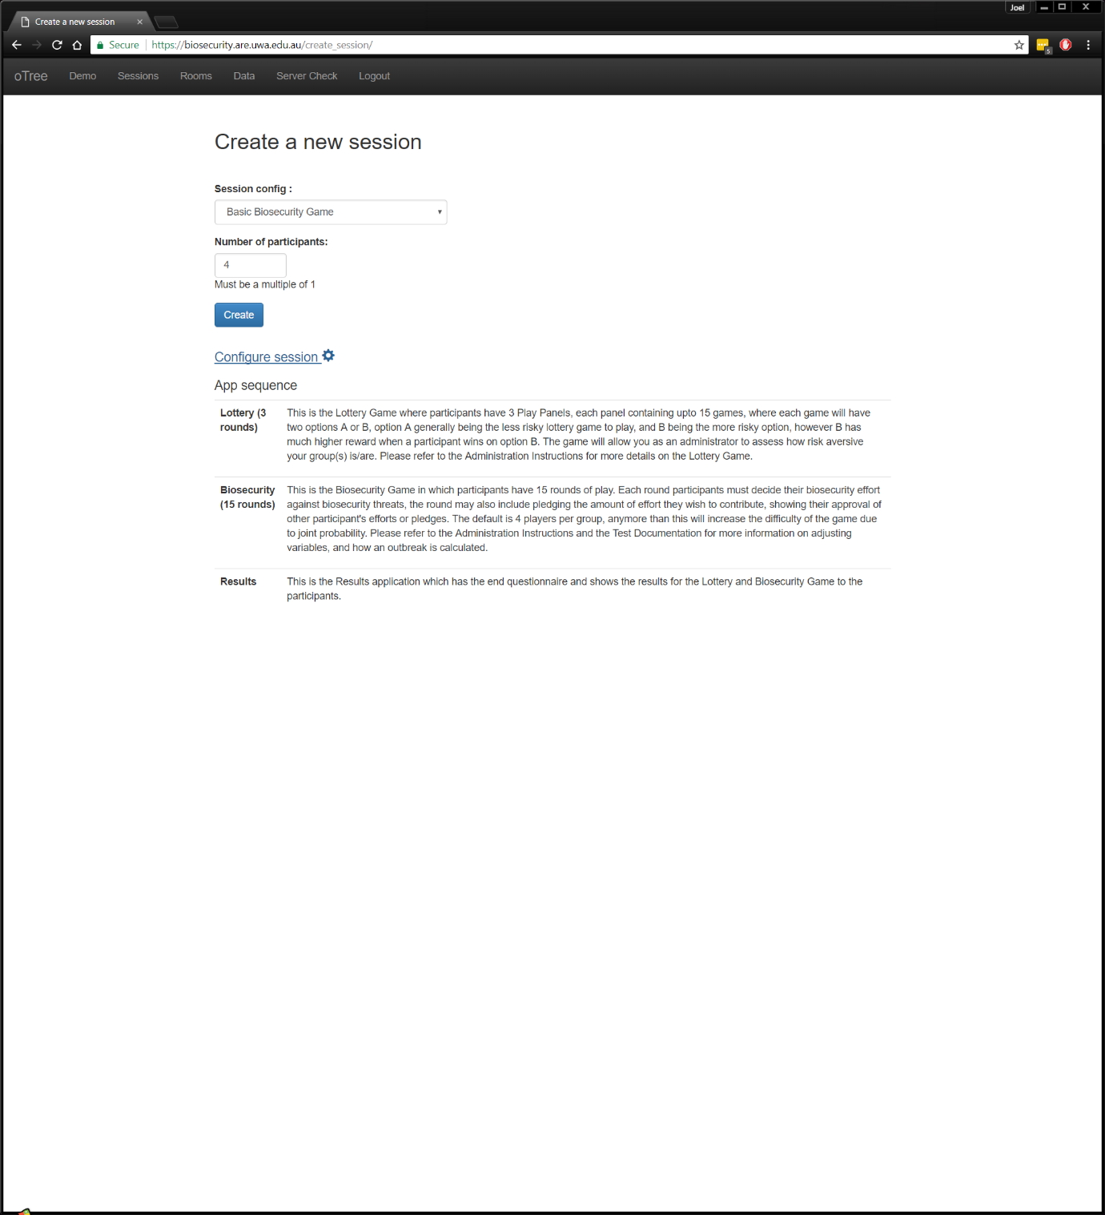

The session config drop down menu, click here to reveal the different session configurations that are built in.

Type in the number of participants for your session.

Click here to configure the session further. See the next page for the explanation of the options.

The above will be the order that the session will run its applications. So, in this case, like in the game with Inigo it will run the Lottery Game, the Biosecurity Game then show the survey and the results of both games.

#### **Configuring a Session**

**In the order that you see them in the image after the table:**

|  |  |
| --- | --- |
| **Variable Name** | **How it changes the game** |
| **Capproval** | Tick this box if you wish to enable approval by contribution. |
| **Papproval** | Tick this box if you wish to enable approval on pledges. |
| **calculator** | Ticked by default, turn this off if you don’t want participants to see the probability that they are not the source of the outbreak while deciding on their biosecurity effort |
| **case** | Ignore this, was used for testing. |
| **Contribution_looper** | This number determines which rounds approval by contribution take place when its enabled. If you put 3 then approval by contribution takes place every 3rd round. |
| **Controlling_cases_for_bots** | Used for testing, ignore. |
| **Dynamic_finances** | Sets random upkeep, max_protection, revenue every turn. Hasn’t been properly tested. |
| **Max_protection** |  |
| **Monitoring** |  |
| **Player_communication** |  |
| **Players_per_group** |  |
| **Pledge** |  |
| **Pledge_looper** |  |
| **Probability_coefficient** |  |
| **Revenue** |  |
| **Set_leader** |  |
| **Starting_funds** |  |
| **Upkeep** |  |
| **Use_browser_bots** |  |
| **Particpation_fee** |  |
| **Real_world_currency_per_point** |  |

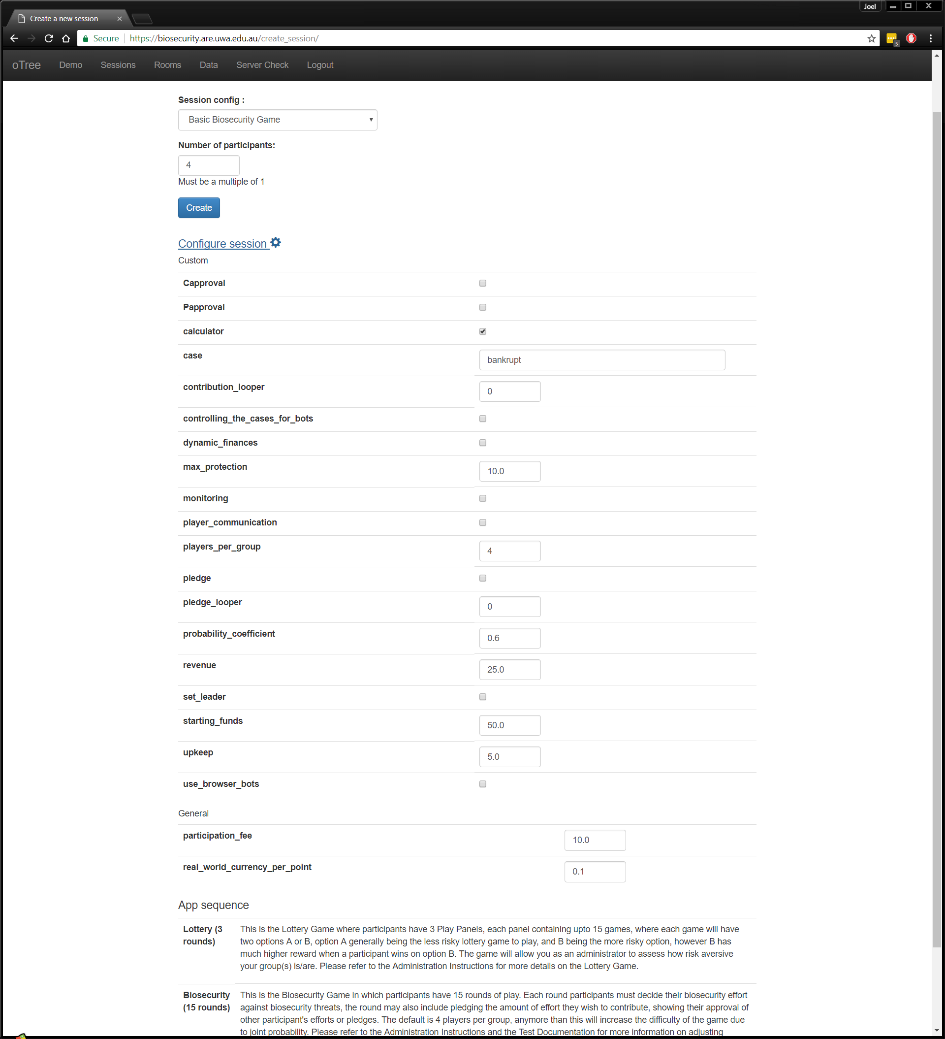

# References

Chen, D., Schonger, M., & Wickens, C. (2016). oTree - An open-source platform for laboratory, online and field experiments. *Journal of Behavioral and Experimental Finance, 9*, 88-97.

oTree. (2017, May). *oTree Documentation*. Retrieved April 2016, from http://otree.readthedocs.io/en/latest/

PCMag. (2017, May). *HTTP Definition from PC Magazine Encyclopedia*. Retrieved from PCMag: http://www.pcmag.com/encyclopedia/term/44501/http

1. The instructions on the images are subject to change and will probably look different to how they appear here
2. Instructions on these pages are subject to change, may differ from the images in the document
3. Instructions on the images are subject to change, they may differ from the game.